**GIT HUB:**

**Week-1 Logbook:**

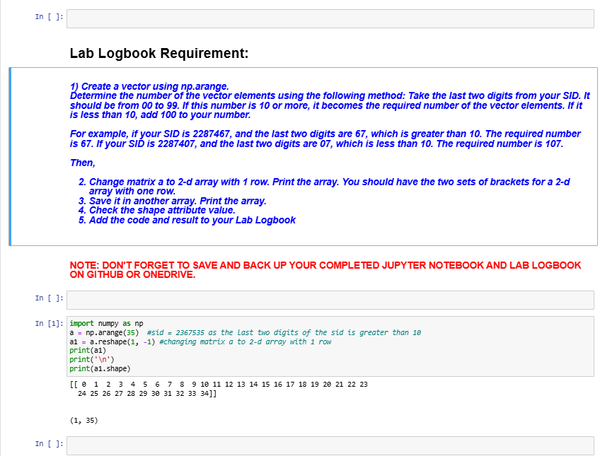

**Week-2 Logbook:**

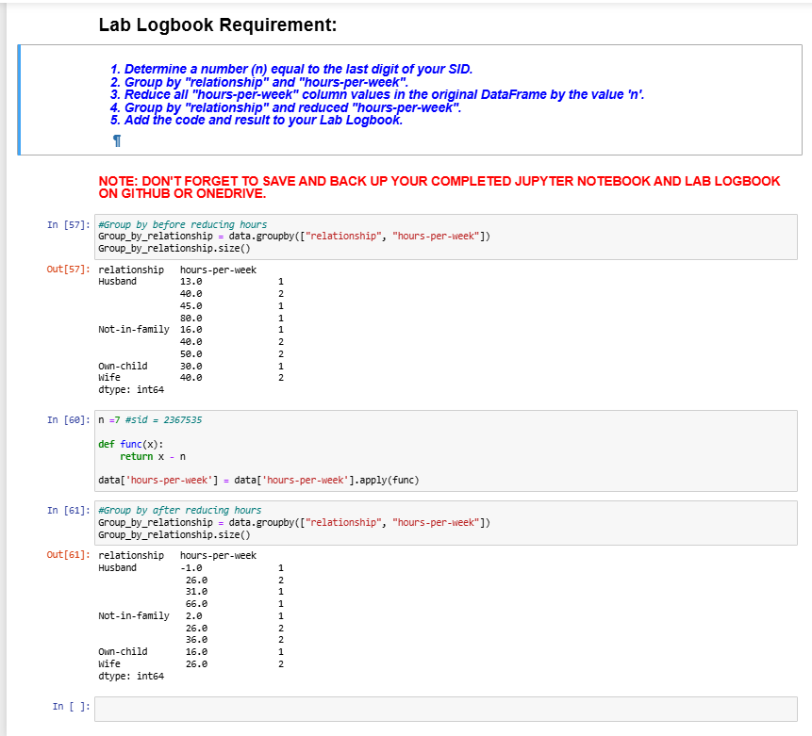

**Week-3 Logbook:**

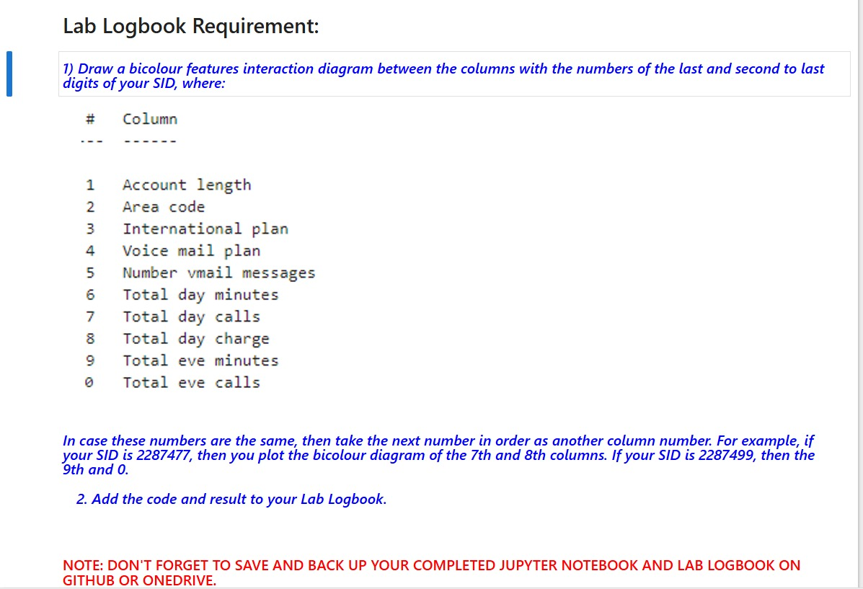

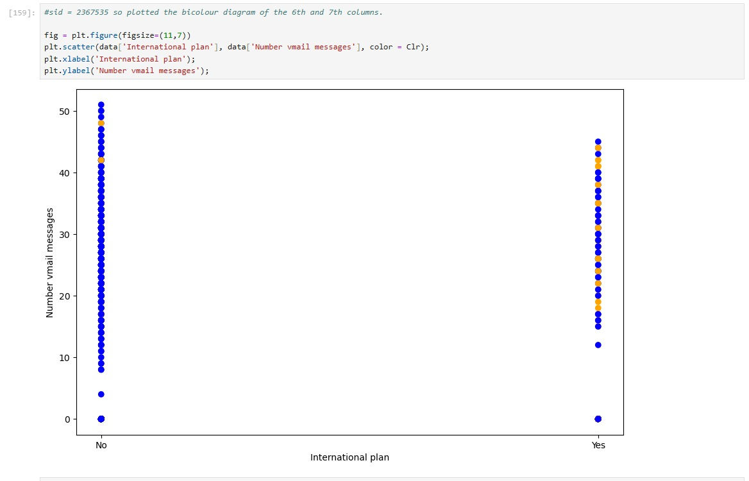

**Week-4 Logbook:**

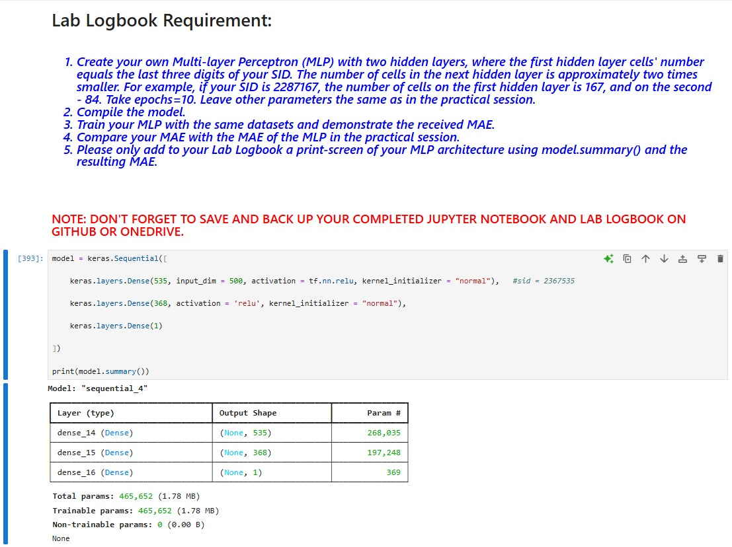

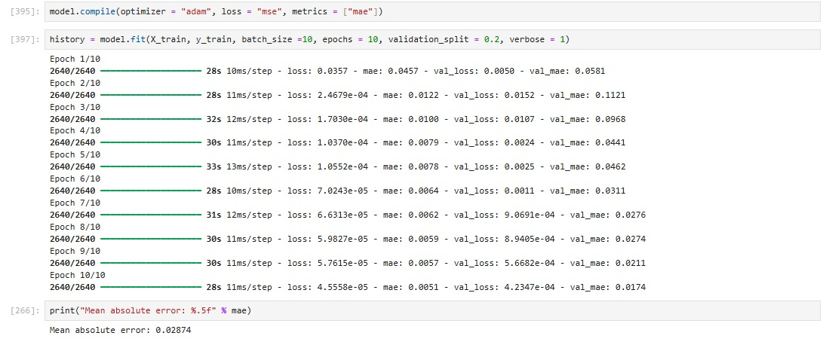

**Week-5 Logbook**

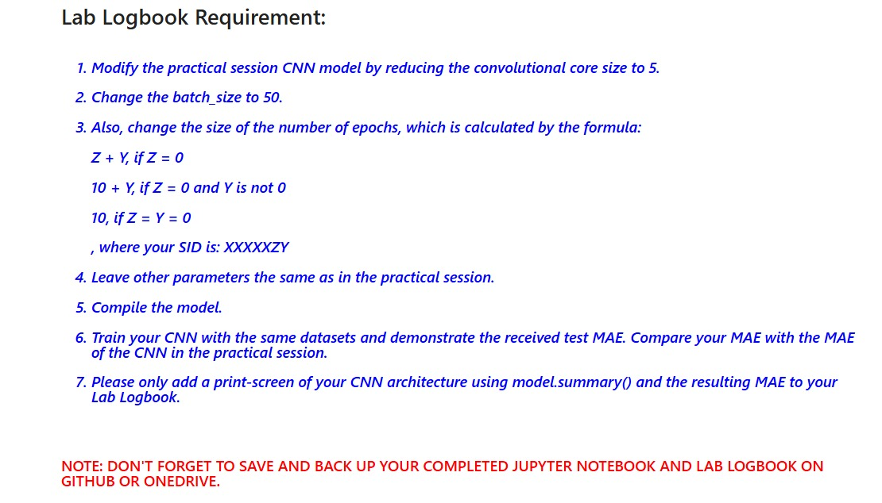

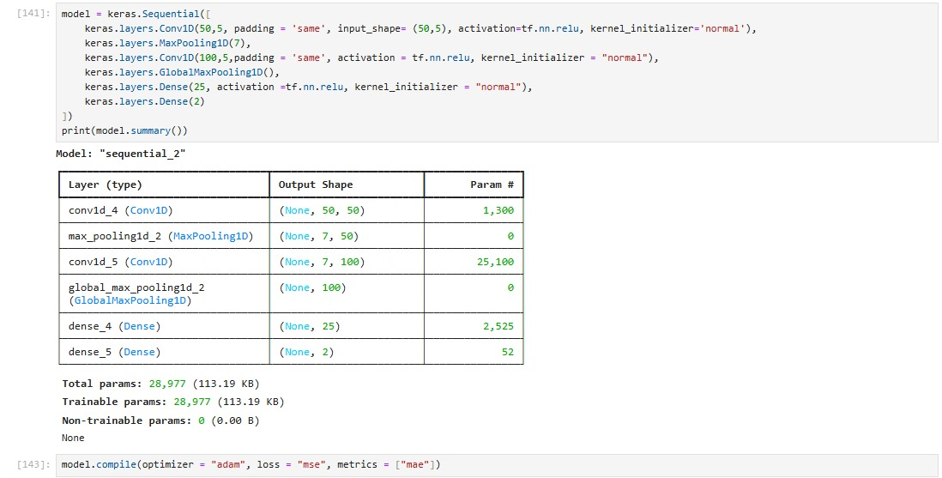

**Logbook MAE:**



**Week-6 Logbook:**

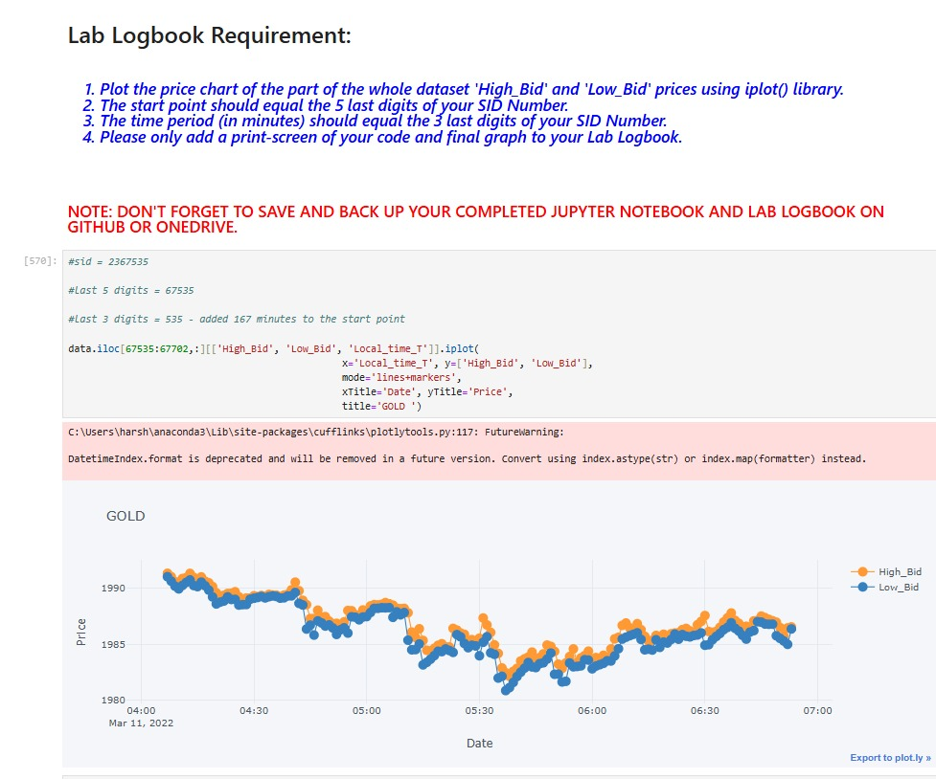

**Week-7 Logbook:**

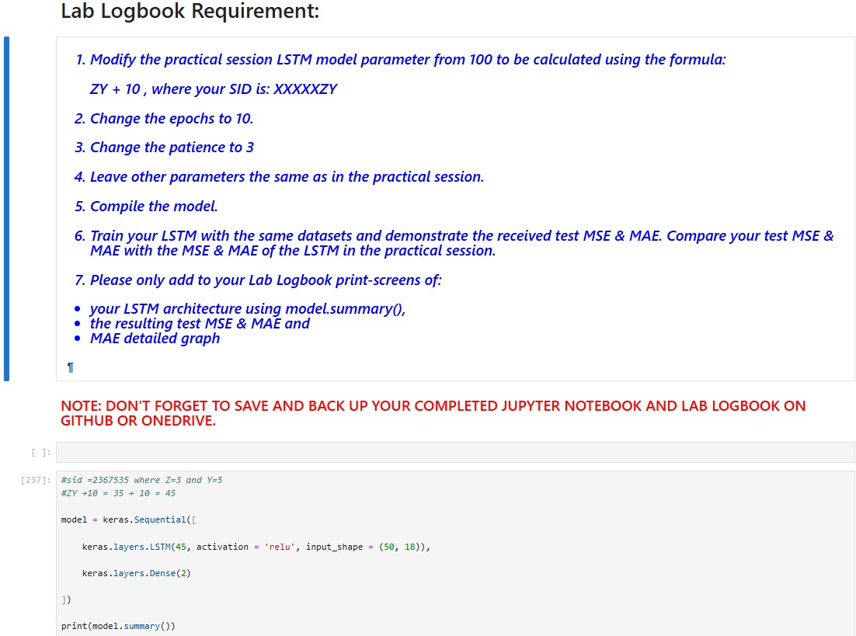

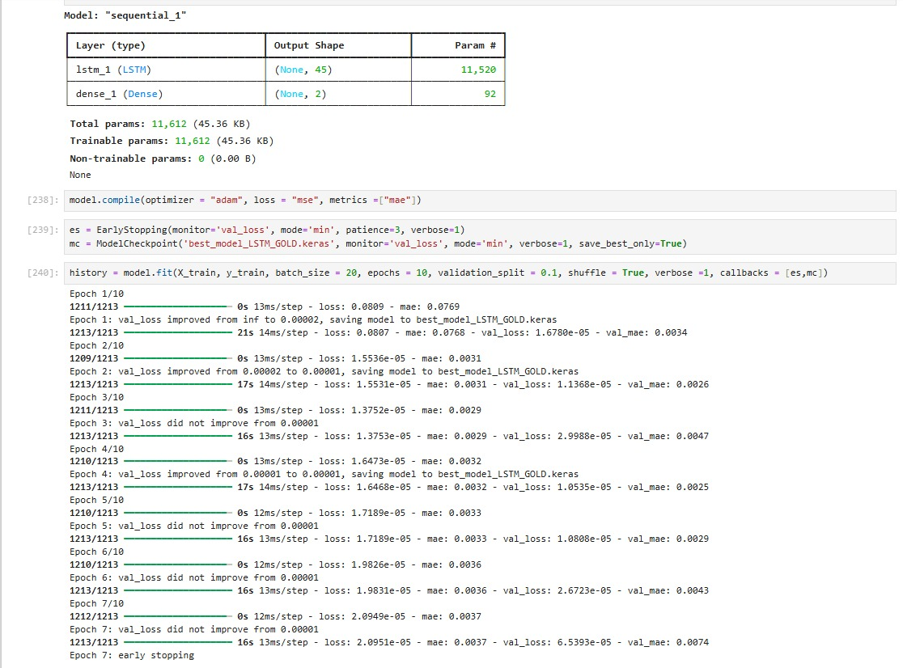

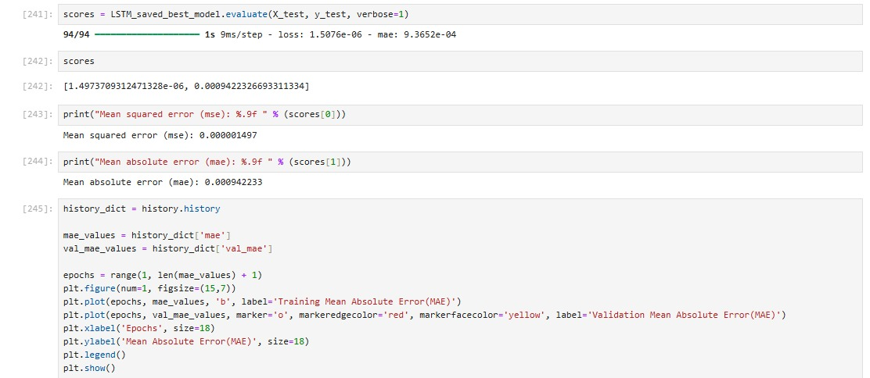

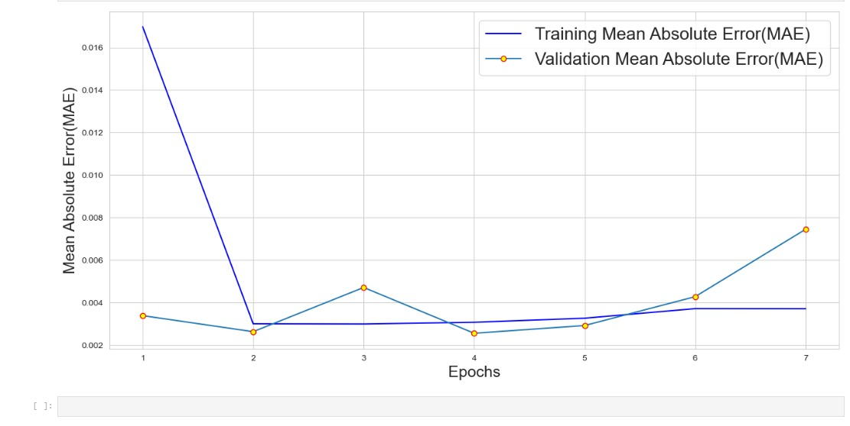

**Week-8 Logbook:**

**Logbook solution:**

**`**

**Week-10 Logbook:**

**Week -11 Logbook:**

